This question is about the following three integrated H-bridge drivers: -

* [L293](http://www.ti.com/lit/ds/symlink/l293d.pdf) or L293D (D = protection diodes added)
* [SN754410](http://www.ti.com/lit/ds/symlink/sn754410.pdf) (protection diodes included)
* [L298](http://www.tech.dmu.ac.uk/%7Emgongora/Resources/L298N.pdf) (no protection diodes)

Time after time the same question keeps coming up - someone is using one of these devices (on a low voltage, usually around 6V or less) and they are just not performing adequately. The reasons are listed further below but my question is this: -

What H-bridge drivers are preferred for applications controlling a low-voltage motor?

**Information**

The L293 and the SN754410 are nearly identical and crucially, if you try and control a 1 amp load, you are faced with dismal performance: -

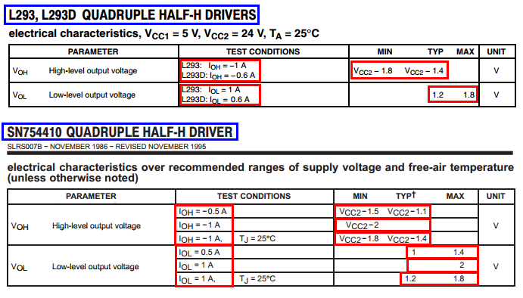

The tables tell you (typical conditions) that the upper transistor drops (loses) about 1.4 volts when driving a 1A load and, the lower transistor drops (loses) about 1.2 volts when driving a 1A load. The upshot is that if you have a 6V, 1A motor and 6V battery, don't expect to see more than 3.4 volts across the motor: -

*VOUT*=6*V*−(1.4*V*+1.2*V*)=3.4*V*

**Worst case scenario is you might only see 2.4 volts across it.**

What about the L298? It's got a nice big heat-sink whereas the L293 and SN754410 are regular-looking chips. Here's what the volt drop (losses) look like: -

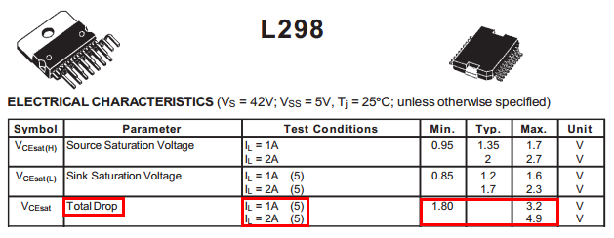

It's the same story - for a 1A load, you can expect to lose up to 3.2 volts and, what you thought might be 6V across your motor, is at best 4.2 volts and at worst only 2.8 volts.

Clearly none of the devices listed are suitable for low voltage applications where the motor might be expected to draw in excess of 0.5 amps.

For low voltages, it seems like the DRV8837 is pretty good: -

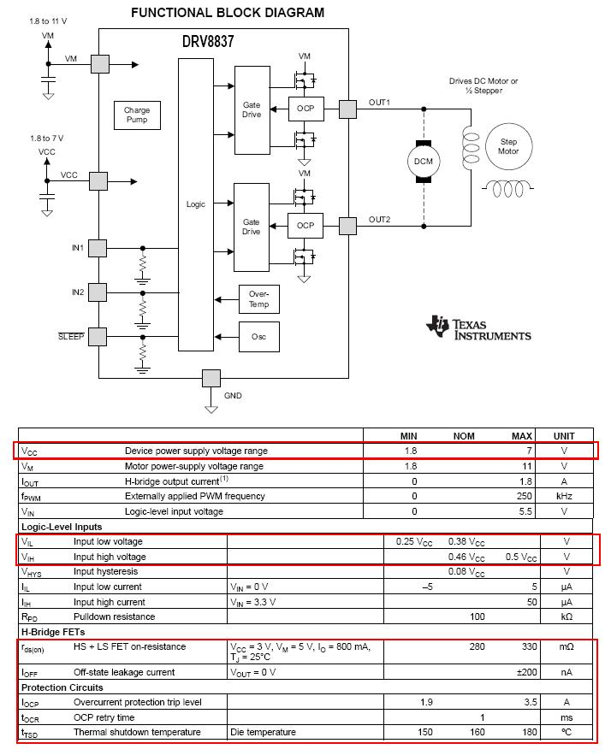

With an 800mA load, the volt drop is: -

*IO*⋅*ROS*(*ON*)

= 800mA x 0.33 ohms = 0.264 volts. At this current, the power dissipation will be 0.8 x 0.8 x 0.33 watts = 211 mW.

Compare this with the L293 power dissipation at about 800mA - maybe about 3V is lost giving rise to a power dissipation of 2.4 watts.

The [VNH5200AS-E](http://www.st.com/web/catalog/sense_power/FM1965/SC1039/PF254068) from ST is also pretty good and is intended for supplies as low as 5.5V up to 18V: -

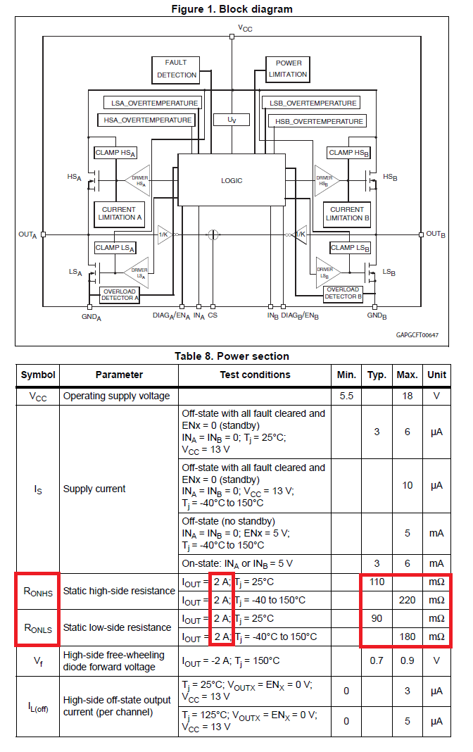

Also, another offering from ST is the [VN5770AKP-E](http://www.st.com/web/catalog/sense_power/FM1965/SC1039/PF250993). It can be configured as separate top-side and low-side MOSFETs (including drivers) or just wired as a H bridge.

There is also the [MC33887](http://www.freescale.com/webapp/sps/site/prod_summary.jsp?code=MC33887) from Freescale (formerly Motorola): -

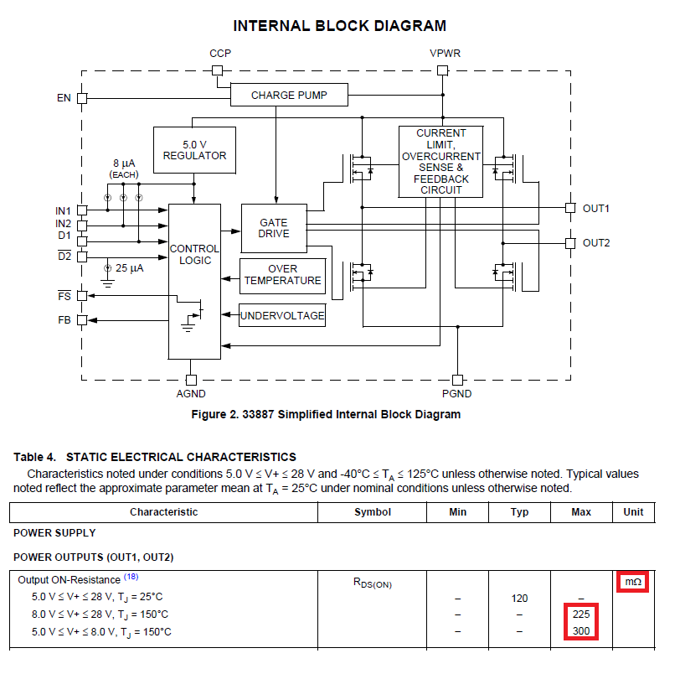

It has on resistances in the low hundreds of milli ohms too.

l298 is better……………… l293d is worse.